**ETA9740 PCB LAYOUT GUIDE**

Editor: ETA Shirley, Date: 2016-8-12

1. Pin Configuration

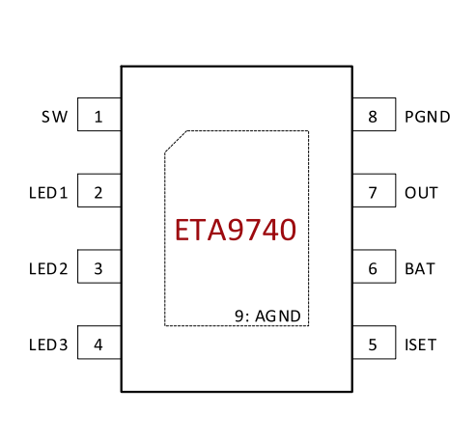

1. Pin6 BAT is not power pin ,while detection single to battery.
2. Pin 7 ,8,1 are power pins.
3. LED1, LED2,LED3,ISET are common single.
4. Schematic diagram for typical application

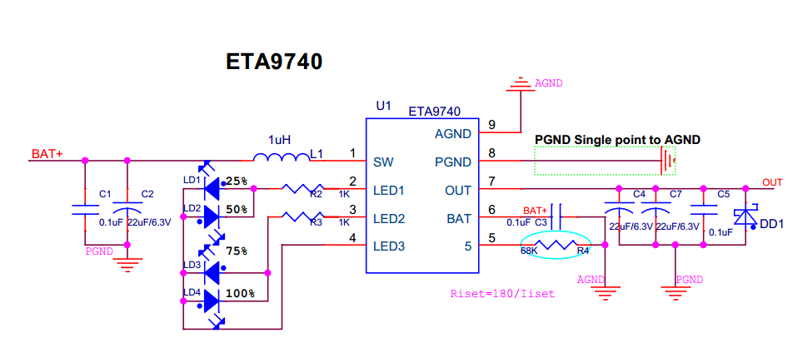

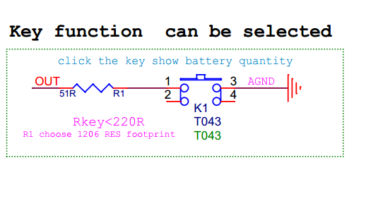

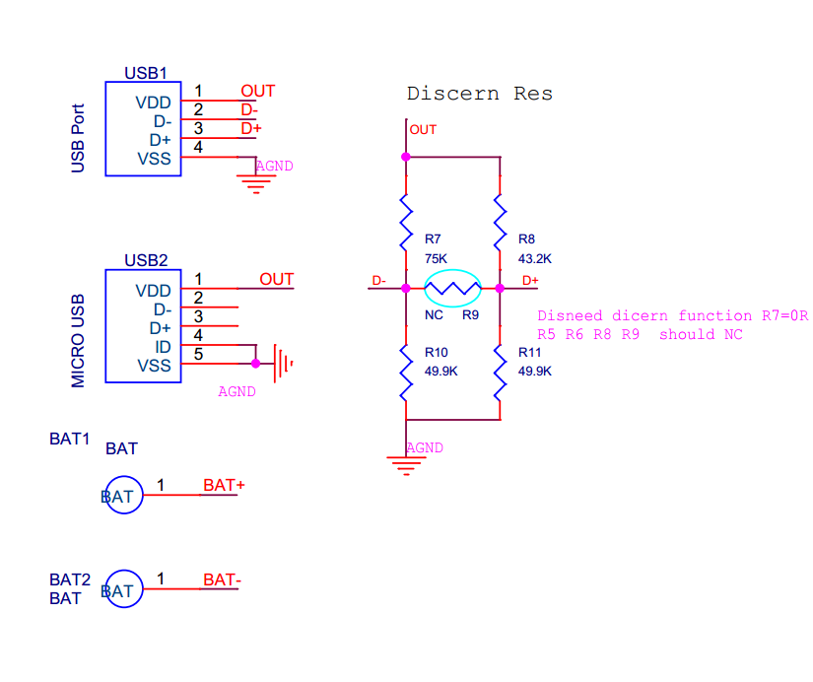

1. PCB STACK

PCB typical thickness: 1.0mm

|  |  |  |  |
| --- | --- | --- | --- |
| Solder mask top | Cu | 0.5OZ/17.5um | sm001.pho |
| Top layer | Cu | 1.5OZ/52.5um | art001.pho |
| Dielectric CORE | FR4 | 860um |  |
| Solder mask bottom | Cu | 0.5OZ/17.5um | sm002.pho |
| Bottom layer | Cu | 1.5OZ/52.5um | art002.pho |

Note: 1OZ=35um=1.4mil

1. PCB DESIGN RULE

|  |  |  |  |  |
| --- | --- | --- | --- | --- |
|  | Trace | Via | Pad | Board |
| Trace | 0.2mm/8mil | 0.2mm/8mil | 0.2mm/8mil | 0.25mm/10mil |
| Via |  | 0.2mm/8mil | 0.2mm/8mil | 0.25mm/10mil |
| Pad |  |  | 0.2mm/8mil | 0.25mm/10mil |
| Board |  |  |  | 0.25mm/10mil |

1. VIA TYPE

|  |  |
| --- | --- |
| Via name |  |
| Single via | 0.4/0.6mm(16/24mil) or 0.3/0.5mm(12/20mil) |
| Power via (GND, VBUS, VOUT……) | 0.5/0.7mm(20/28mil) or 0.4/0.6mm(16/24mil) |

Note: Via to via can tangent but not overlap.

1. PCB PLACEMENT

|  |  |  |
| --- | --- | --- |
| LAYER | PLACEMENT | LAYOUT |
| Top | Component | Power trace |
| Bottom | Cap , Res | Single trace& Power trace |

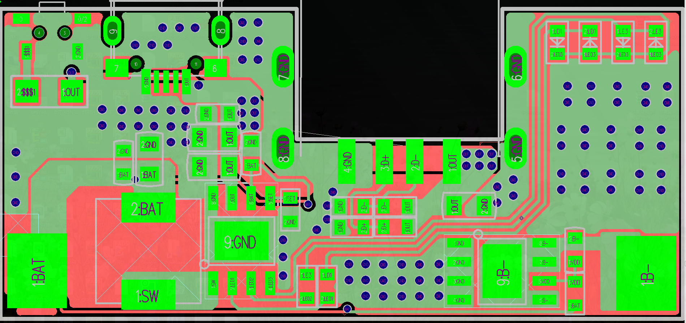

1. OUT cap should be place close to IC pin 7&8, otherwise output need 2 caps with 0805 footprint and 1 cap with 0603 footprint.

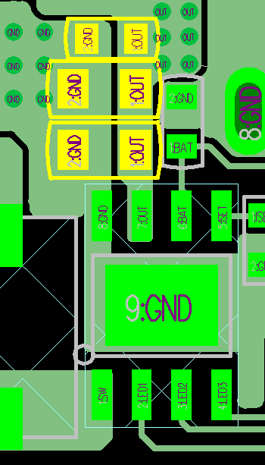

1. Inductance should place close to IC make sure that SW trace could trace as short as possible.

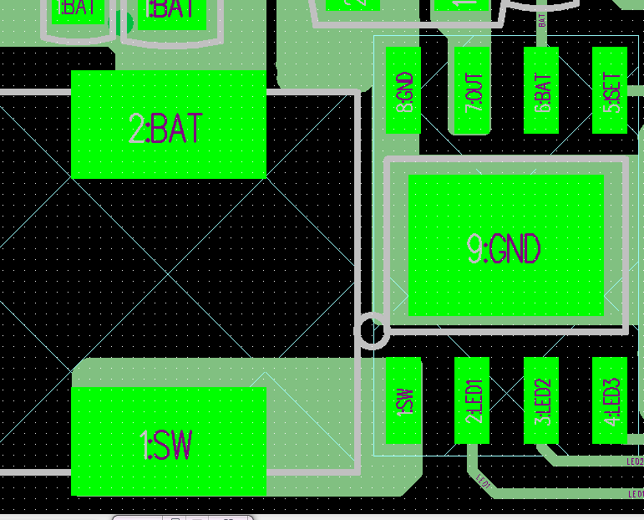

1. Two caps are needed between inductance and battery welding point.

Bat trace must place from inductance to cap to welding point.

PS: Caps: 0805 cap &0603 cap

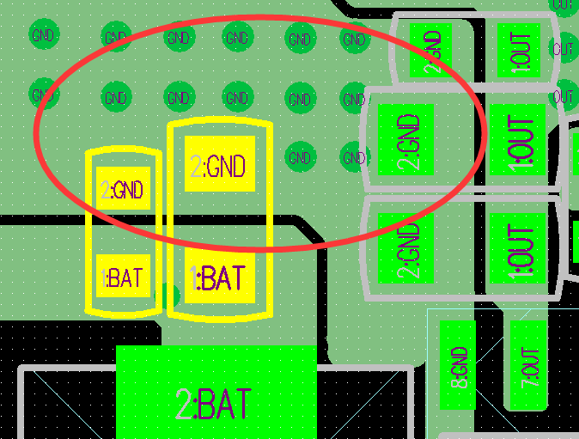

1. Pin8 must connect to pin9

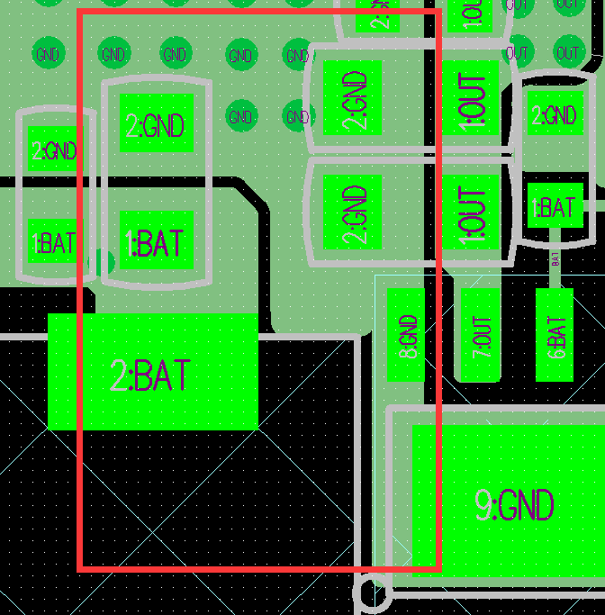

1. Place a cap with 0805 footprint close to USBA

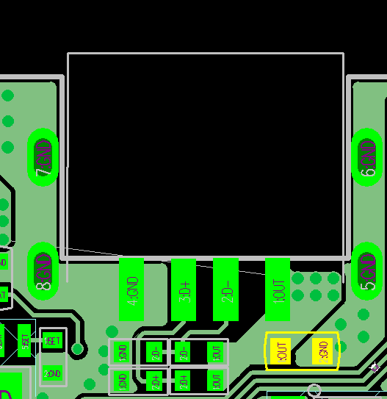

1. ESOP pin9 needs some via dissipate heat

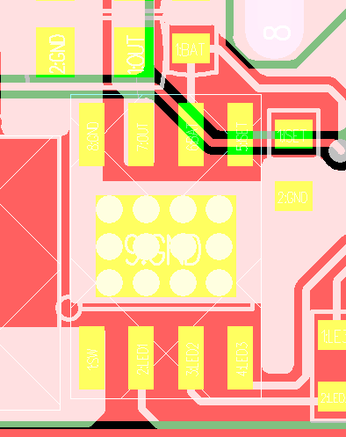

1. Bat sense trace need far away from power current, it can put a via near the cap and go on the bottom side.

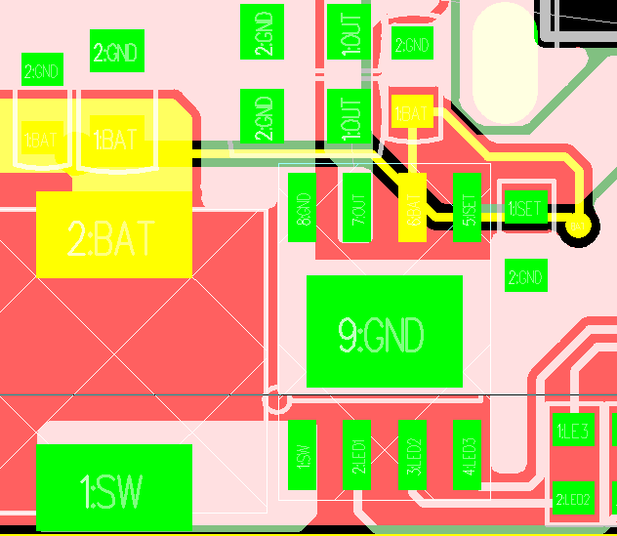

1. Key need a 1206 Res series connection to output.

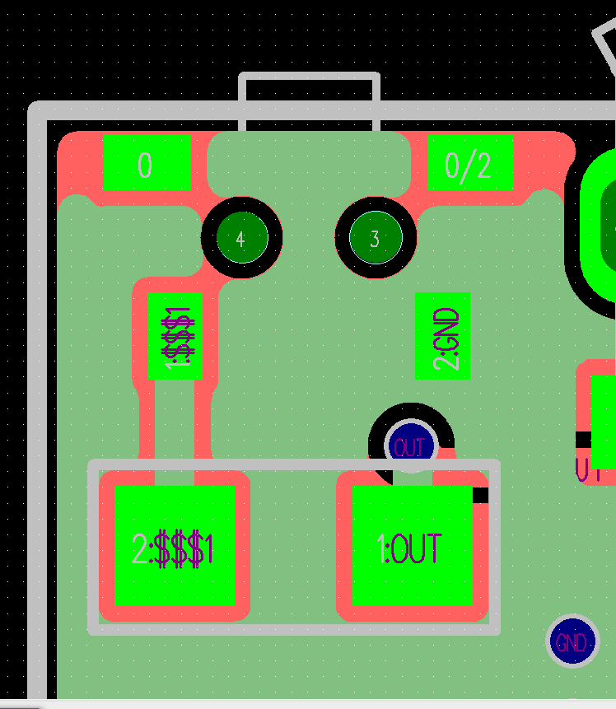

1. PLACEMENT RULE DITAIL
2. Power part:
3. Component need to put compacted.
4. Trace make sure that rout as short as possible.
5. ETA9740 support 2.4A charge and discharge, so output trace rout wide>1.5mm

If the trace is larger than 25mm, please route wide>2.0mm.

1. Single part:
2. Bat sense need far away for power part.
3. LED current limited res can place anywhere on the board.
4. Layout EMI subjection
5. Power current need more via on the board
6. Power loop can be as small as possible.
7. Can put some 0603 caps on the power trace for example: OUT……